Homework 2

STAT:3210 Experimental Design and Analysis

Yubing Li

**1. Problem 2.32:**

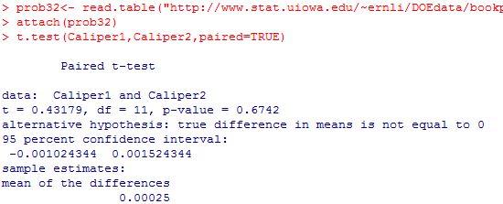**(a) Paired T-test: (H0: µ1 - µ2 = 0 vs. Ha: µ1 - µ2 ≠ 0)**

The p-value of the paired t test is 0.6742, which is larger than α level = 0.05. We cannot reject the null hypothesis that the means of the population is equal. In general, there’s no significant difference between the means.

**(b) P-value:** The p-value is 0.6742.

**(c) 95% CI:** The 95% CI of the mean difference is (-0.001024, 0.001524)

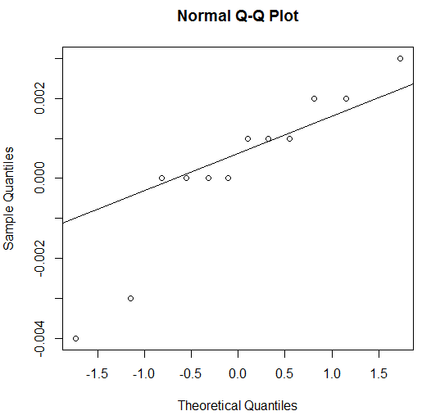

**(d) Normality Assumption:**



In general, the values of the difference are close to the diagonal line, which indicates that the difference are following the approximately normal distribution. Therefore, the normality assumption for the difference are not violated.

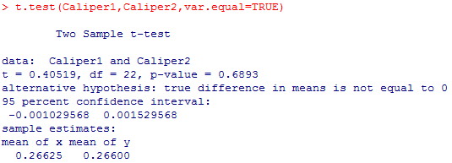**(e) Pooled T-test: (H0: µ1 - µ2 = 0 vs. Ha: µ1 - µ2 ≠ 0)**

The p-value of the paired t test is 0.6893, which is larger than α level = 0.05. We cannot reject the null hypothesis that the means of the population is equal. In general, there’s no significant difference between the means. The pooled t test has the same result as the paired t test.

**(f) Summary:**

In both of the tests, the result of hypothesis testing for the mean difference is the same. There’s no significant difference between two means.

However, in paired t test, the variability of the test is smaller than the pooled test. It leads to a smaller denominator of the test. As a result, the paired t-test is more sensitive than the pooled t-test. (tpaired = 0.4318 > tpooled = 0.4052).

On the other hand, the degree of freedom in pooled test is 22, which is larger than the df = 11 in paired test. As a result, the pooled t-test is more sensitive than paired test.

**2. Problem 2.24:**

**(a) Hypothesis Testing:**

Null hypothesis: H0: µ1 - µ2 = 0 vs. Alternative hypothesis: Ha: µ1 - µ2 ≠ 0

Where µ1 is the mean net volume filled by machine 1 and µ2 is the mean net volume filled by machine 2.

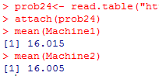**(b) Conclusions:**



Since the p-value = 0.17713 is larger than α = 0.05, we cannot reject the null hypothesis. In other word, there’s not sufficient evidence to say that the mean volumes different. The means of net volumes for filling bottles by two machines are generally considered to be equal.

**(c) P-value:** the p-value is 0.17713.

**(d) 95% CI:** The 95% CI of the mean difference is (-0.004523, 0.024523)

**(e) Sample size:** The necessary sample size is n = 22.

**(f) Two-sided z-test:**

i) The power of the test is 0.27124.

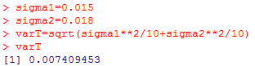

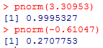

ii) The required sample size is at least n1 = n2 = 58, to reject H0 under the alternative hypothesis H1: µ1 - µ2 = -0.01 to have a power of 0.9.

**3. Problem 2.29:**

**(a) Hypothesis Testing: (H0: µ1 = µ2 vs. Ha: µ1 > µ2)**

### Where µ1 is the mean thickness under 95 [℃](http://graphemica.com/%E2%84%83) and µ2 is the mean thickness under 100 [℃](http://graphemica.com/%E2%84%83).

### (R output is on the next page)

### Since the p-value is 0.009059, which is smaller than α level = 0.05, we reject the null hypothesis and say there’s sufficient evidence to conclude that the higher baking temperature results in wafers with a lower mean photoresist thickness.

### (b) P-value: The p-value for the test hypothesis is 0.009059

### 

### 

**(c) Boxplots:**

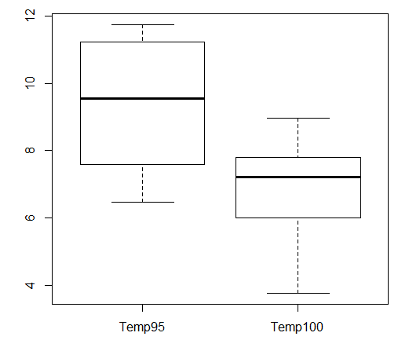

We can tell from the boxplots that the median thickness of under 95 [℃](http://graphemica.com/%E2%84%83) is much higher than the median thickness under 100 [℃](http://graphemica.com/%E2%84%83). In addition, the variation of thickness is much higher under 95 [℃](http://graphemica.com/%E2%84%83) and the overall spread is similar under both temperature. The boxplot of temp95 hardly overlaps the boxplot of temp100. In general, the boxplots agree to the result we get from hypothesis testing.

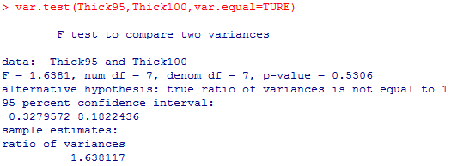**(d) Hypothesis Testing for Variance: (H0: σ12 = σ22 vs. Ha: σ12 ≠ σ22)**

Since the p-value is 0.5306, which is larger than α level = 0.05, we fail to reject the null hypothesis and say there’s insufficient evidence to conclude that the variances are unequal.

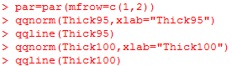**(e) Normality Assumption:**

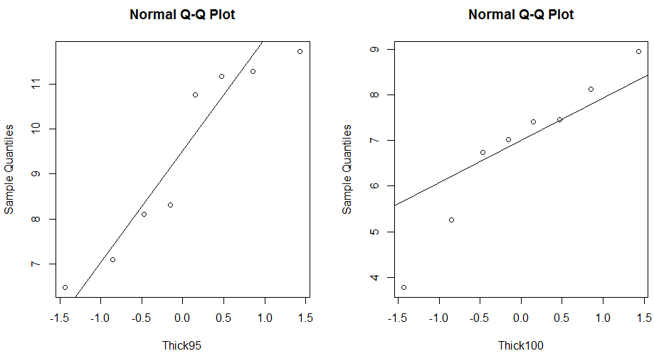

Though there’re small outliers in q-q plot under temp100, other values are generally close to the diagonal reference line under both temperature. Generally speaking, under both temp95 and temp100, the distributions follow the approximately normal distribution.

**(f) Find Power:**

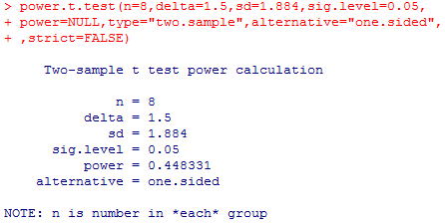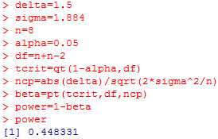i) “by hand”: power = 0.448331 “by power.t.test ( )”: power = 0.448331

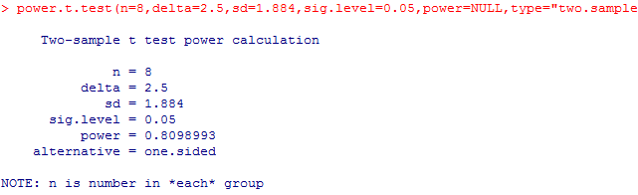ii) The power is 0.8098993

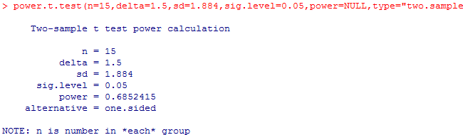iii) The power is 0.6852415

iv) Yes, both power in ii) and iii) are bigger than power in i).

**(g) Sample Size:**

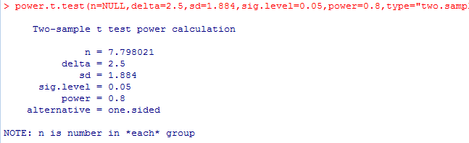i) Fot power = 0.8, delta = 2.5, we need at least n = 8.

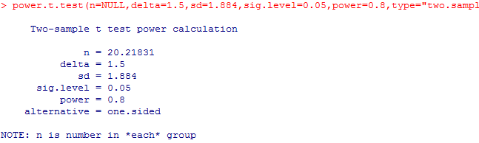ii) For power = 0.8, delta = 1.5, we need at least n = 21.

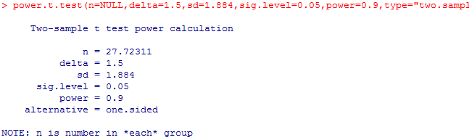iii) For power = 0.9, delta = 1.5, we need at least n = 28.

iv) Yes, both necessary sample size in ii) and iii) are larger than that in i).